1. Nintendo Critic Scores Compared to Global Sales

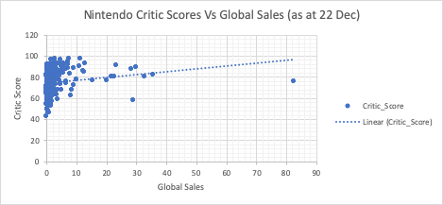

DMack

HW_Task3_FilterGameSales